**Spectral Fitting**

**for Monophosphonated Trityl Radicals**

**User Guide**

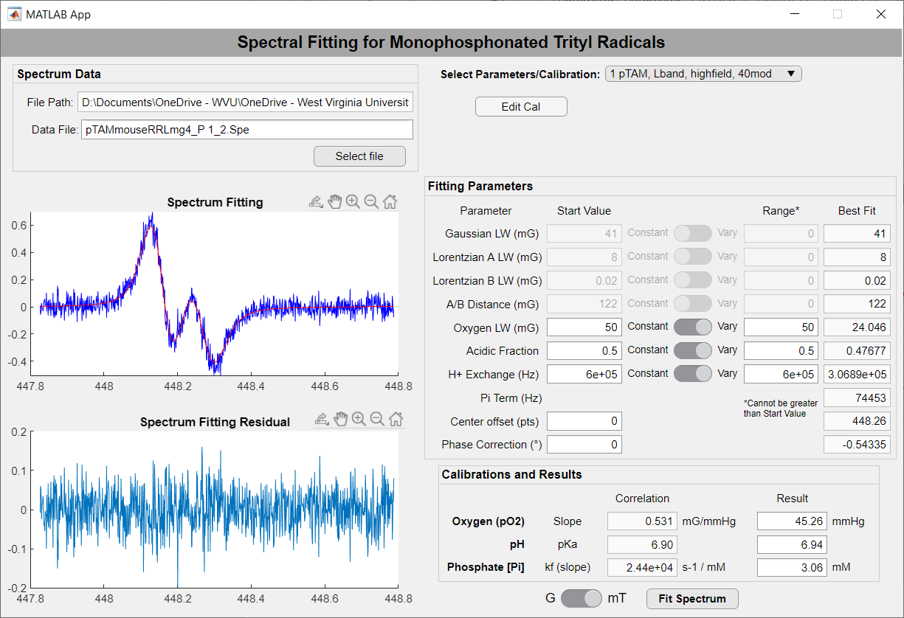

Driesschaert Lab

In Vivo Multifunctional Magnetic Resonance Center, Robert C. Byrd Health Sciences Center

Department of Pharmaceutical Sciences, School of Pharmacy

West Virginia University, Morgantown, WV, 26506, USA

**Table of Contents**

**Background Information about Monophosphonated Trityl EPR** 3

**Definitions** 4

Fitting Parameters 4

Calibration and Results 4

**Installation** 5

Option 1 – standalone executable 5

Option 2 – installation 5

**Spectra Fitting** 6

Selecting a Spectrum File 6

Fitting a Spectrum with an Existing Calibration 7

Editing a Calibration 9

**Calibration** 10

Starting a New Calibration 10

Determining the Fitting Parameters 10

Acidic Peak (Outer Peaks) Linewidths 10

Basic Peak (Inner Peaks) Linewidths 11

A/B Distance 12

Alternate - Both Peaks Linewidths (plus A/B Distance) 13

Calibrating Slopes 14

Oxygen Slope of Acidic Peak (Outer Peaks) 14

Oxygen Slope of Basic Peak (Inner Peaks) 15

Alternate - Oxygen Slope of Acidic/Basic Peaks at pH 7 16

Phosphate Slope and Intercept 17

pKa 18

Saving the New Calibration 18

**Additional Notes** 19

Saved Calibration File 19

# **Background Information about Monophosphonated Trityl EPR**

Example monophosphonated trityl (pTAM/HOPE) full EPR signal using L-band EPR spectroscopy.

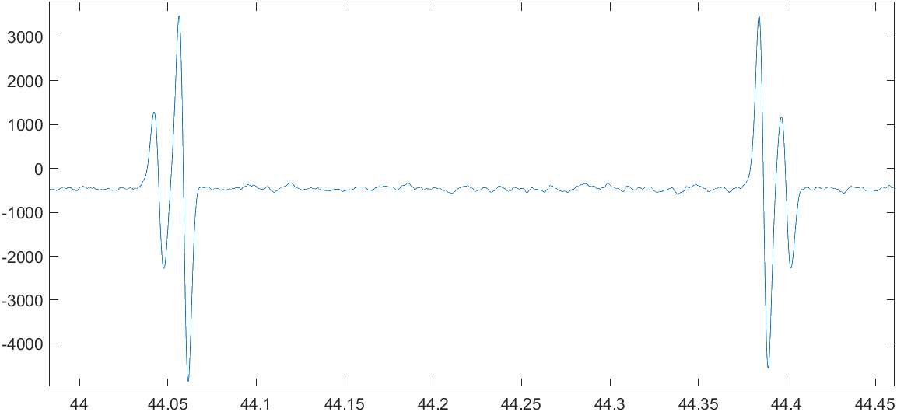

lowfield component A/B distance < 0

Basic peak

Acidic peak

highfield component A/B distance > 0

Acidic peak

Basic peak

*Note – all instructions included in this guide utilize half spectra (highfield/lowfield components) of the monophosphonated trityl EPR signal. Full signal spectra may also be used by adjusting the center offset to align with the component of interest.

# **Definitions**

## **Fitting Parameters**

* **Gaussian LW** (milliGauss) – Gaussian contribution to line shape for both the acidic and basic peaks
* **Lorentzian A LW** (milliGauss) – Lorentzian contribution to line shape for the acidic peak with no oxygen
* **Lorentzian B LW** (milliGauss) – Lorentzian contribution to line shape for the basic peak with no oxygen
* **A/B Distance** (milliGauss) – Distance between acidic and basic peaks in a buffer free solution
* **Oxygen LW** (milliGauss) – Lorentzian linewidth broadening due to oxygen
* **Acidic Fraction** – fraction of pTAM in the acidic state (H-pTAM3-)
* **H+ Exchange** (1/s) – proton exchange rate (ka)
* **Pi Term** - adjustment to the H+ exchange rate based on pH and Ka of the buffer (phosphate), linear relationship with phosphate concentration

Pi Term=

* **Center Offset** (points) – adjustment to the center field position
* **Phase Correction** (degrees) – adjustment to the phase. To flip, enter 180.
* **Start Value** – Center of the fitting range for the parameter of interest. If the parameter switch is set to *Constant* and/or the Range is 0, the Start Value is the assigned value for that parameter.
* **Range** – Defines how much the parameter can vary when fitting in the positive/negative direction of the *Start Value*. (Example – If Start value = 100, Range = 50, the fitting range will be 50-150). The *Range* cannot be greater than the absolute value of the *Start Value* because the fitting parameters cannot below zero (except **A/B Distance** is negative when looking at the low-field component).
* **Best Fit** – The result for the corresponding parameter for the best fit of the spectrum.

## **Calibration and Results**

* **Oxygen** (pO2)
  + **Slope –** The linear relationship between oxygen-induced line broadening (*Oxygen LW, mG*) and the partial pressure of oxygen (mmHg).
  + **Result –** The oxygen partial pressure derived from the *Oxygen LW* of the fitted spectrum and the Oxygen slope.
* **pH** 
  + **pKa –** ThepKa of pTAM between the acidic and basic states : pTAM3- ↔ pTAM4-
  + **Result –** The pH derived from the *Acidic Fraction* of the fitted spectrum and the pKa.
* **Phosphate**
  + **Slope –** The linear relationship between the *Pi Term* (1/s) and the inorganic phosphate concentration [Pi] (mM).
  + **Result** – The inorganic phosphate concentration (mM) derived from the *H+ Exchange* and *Pi Term* of the fitted spectrum and the phosphate slope.

# **Installation**

You have 2 options for “installing” this software on your PC :

1. Using the executable in standalone form (requires MatLab Runtime)
2. Run the installation file *pTAMAppInstaller_mrc.exe* (includes MatLab Runtime).

Disclaimer – this software was developed and tested in a Windows 10 environment and may not run as expected on Macs and Linux operating systems.

## Option 1 – standalone executable

1. Unzip the file containing the application files, *pTAM_Fitting_App.exe* and *pTAM_cal.txt*.
2. Store these files together wherever you would like to tun the program from.
   1. This will perform best if in a file that has writable permissions.
3. To run the executable, you will need to install MatLab Runtime (if not already installed) which can be found here:

https://www.mathworks.com/products/compiler/matlab-runtime.html

## Option 2 – installation

1. Run *pTAMAppInstaller_mrc.exe* (includes the MatLab Runtime) or pTAMAppInstaller_web (downloads Matlab Runtime).
2. The first screen provides a summary of the software. Click Next.
3. The second screen allows you to select the installation folder. You can also choose to add a shortcut. Choose and Click Next. (Defaults to “C:\Program Files\pTAM_Fitting_App”)

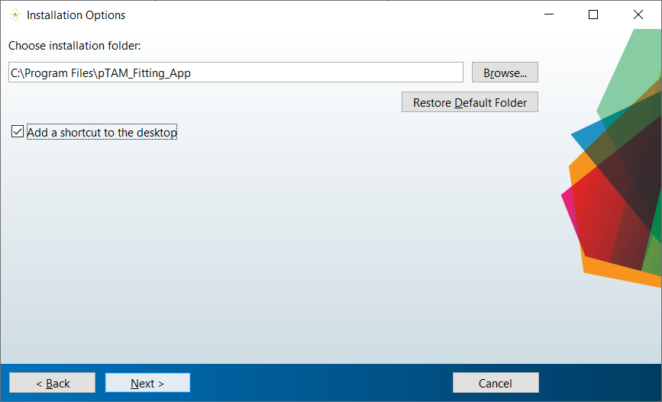

1. The third screen checks for Matlab Runtime. Review and click Next.
2. The fourth screen is a confirmation page. Review and click Install.
3. Installation is complete when the installer reads “Installation completed successfully.”
   1. The original *pTAM_cal.txt* file for saving calibrations will be installed under the same file as the application. Because the Program Files folders generally do not have writable permissions, a writeable copy will be made to your user directory (C:\Users\[username]\pTAM_Fitting_App). If a user directory is not available, a writeable copy will be made to the deployable archive (generally Temp app data).

# **Spectra Fitting**

## **Selecting a Spectrum File**

1. Click **Select File** in the top left box.

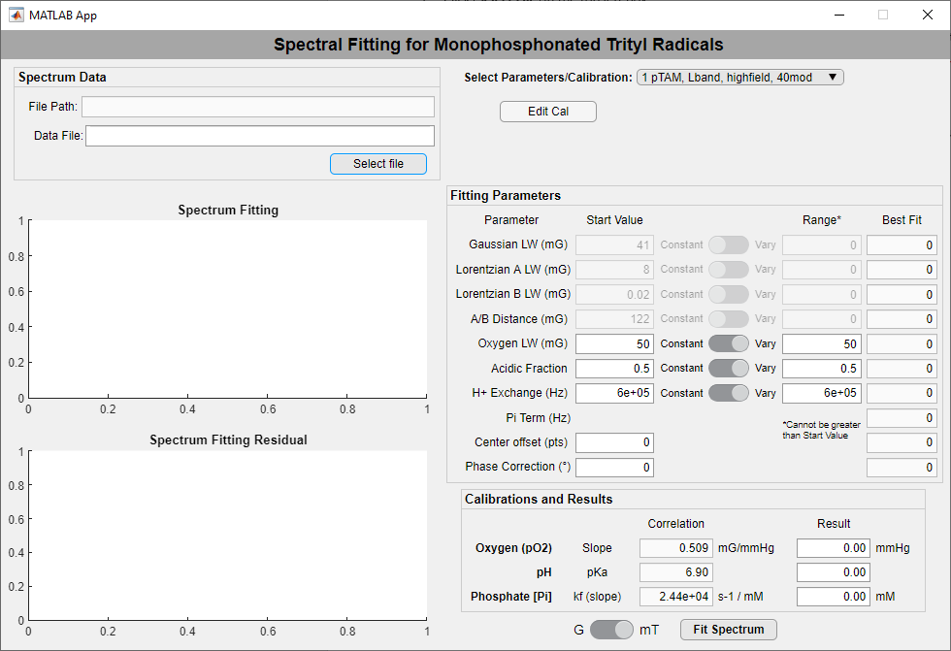

1. Navigate to the location on your computer of your spectrum file and select the file of interest.

*Note - The software currently supports “.DSC”, “.DTA” (Bruker), or “.SPE” (Magnettech) files.

1. Click **Open** .
2. The spectrum preview will be displayed in the graph below with a blue line.

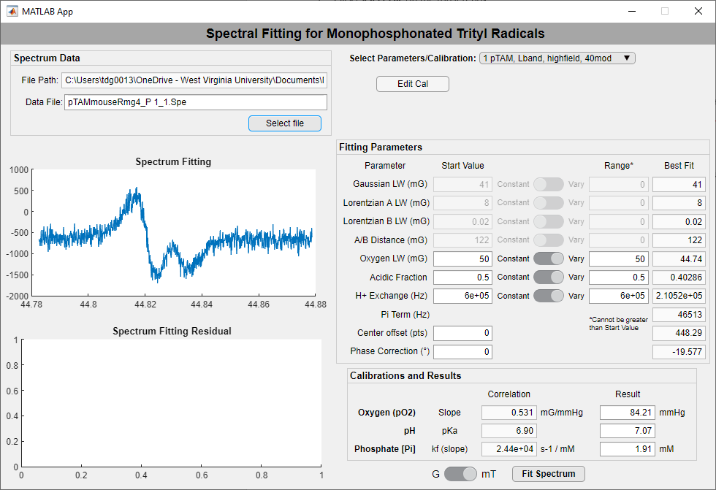

1. Choose whether the spectrum is in Gauss (G) or millitesla (mT) before fitting the spectrum. (DSC and DTA files will default to G; SPE files will default to mT) See the next section (page 7) for fitting.

*Note – Once in the correct file path/directory, you may type changes to the Data file name to easily switch between files in the same path.

## **Fitting a Spectrum with an Existing Calibration**

1. Choose the saved calibration from the drop-down menu at the top right of the application.

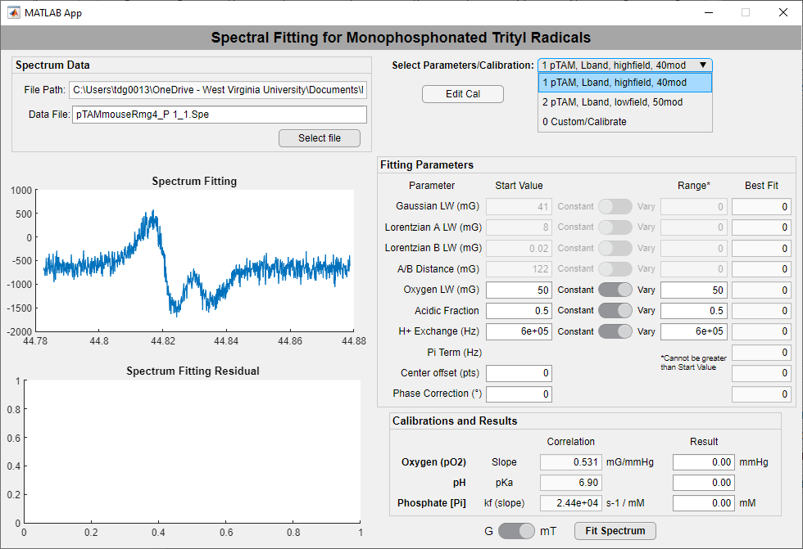

1. Ensure that you have a spectrum file selected (See page 6).
2. Choose whether the spectrum is in Gauss (G) or millitesla (mT), if not already done.
3. Ensure that the Oxygen LW, Acidic Fraction, and H+ Fraction parameters are set to vary an appropriate amount.

*Note – The varying Range cannot be greater than the absolute value of Start Value (parameters cannot be negative).

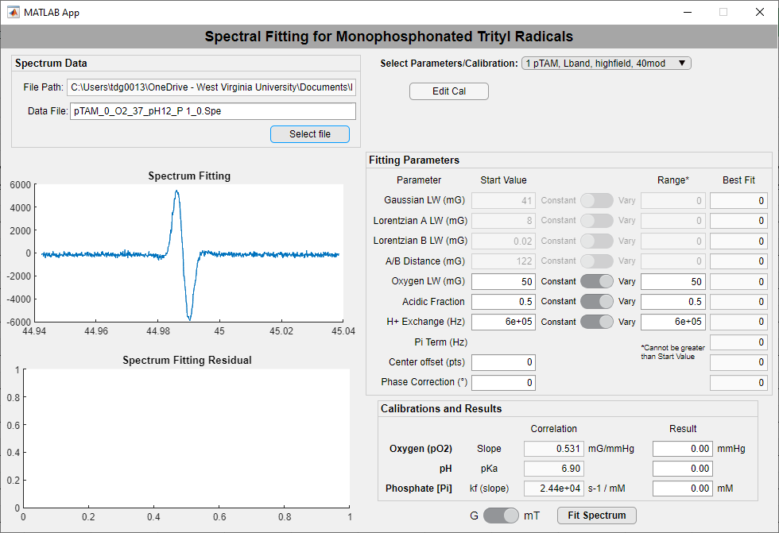

1. Click **Fit Spectrum** .
2. The fitted spectrum (red line) will appear in the graph with the experimental data (blue line). The residual difference between the experimental and fitted spectra will appear in the graph below.
3. The *Best Fit* for the parameters **Oxygen LW**, **Acidic Fraction**, and **H+ Fraction** (and the related **Pi Term**) will appear to the right.

*Note – The Pi term = (Hz) and has a linear relationship with the inorganic phosphate concentration.

1. The resulting **Oxygen Partial Pressure** (mmHg), **pH**, and **Inorganic Phosphate Concentration** (mM) will be calculated based on the slopes and pKa shown, and they will be displayed at the bottom right.

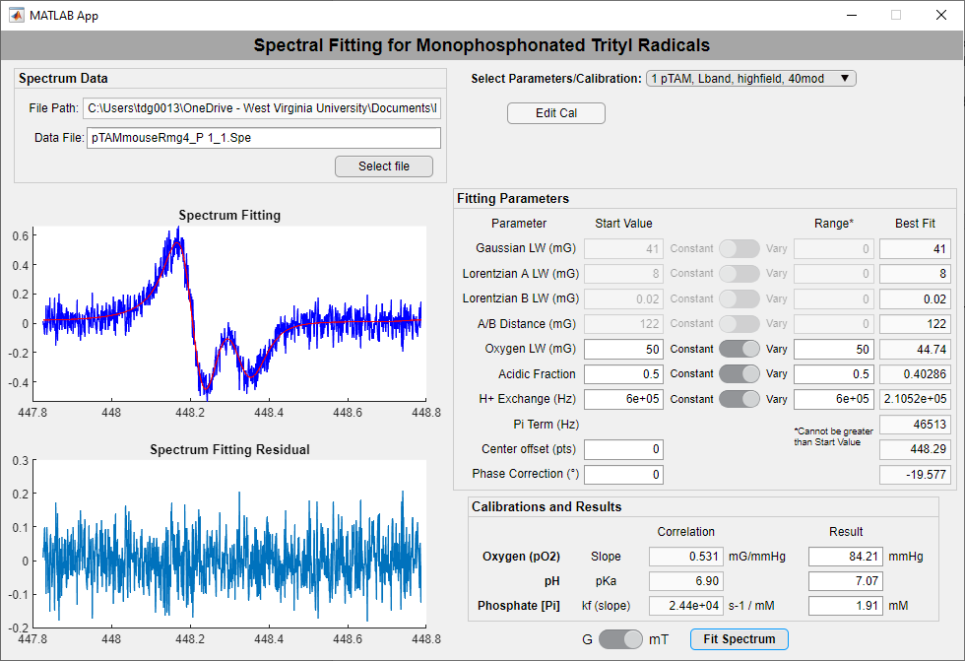

1. If the spectrum does not successfully fit due offset positioning, adjust the **Center Offset** to move the simulated spectrum left (negative) or right (positive) and re-click **Fit Spectrum** . Intervals of 25 are recommended.

 

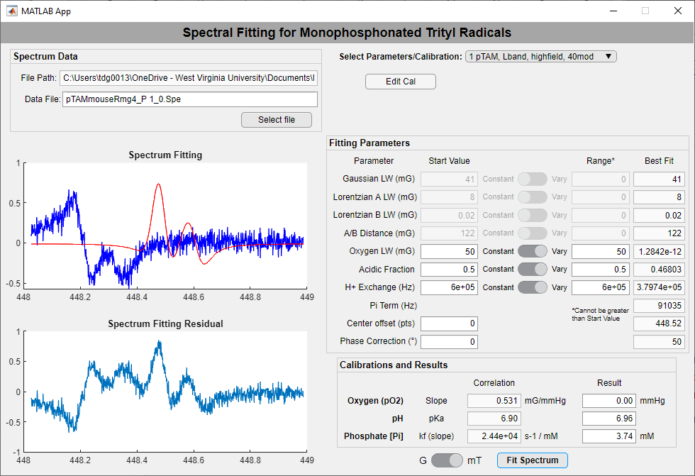 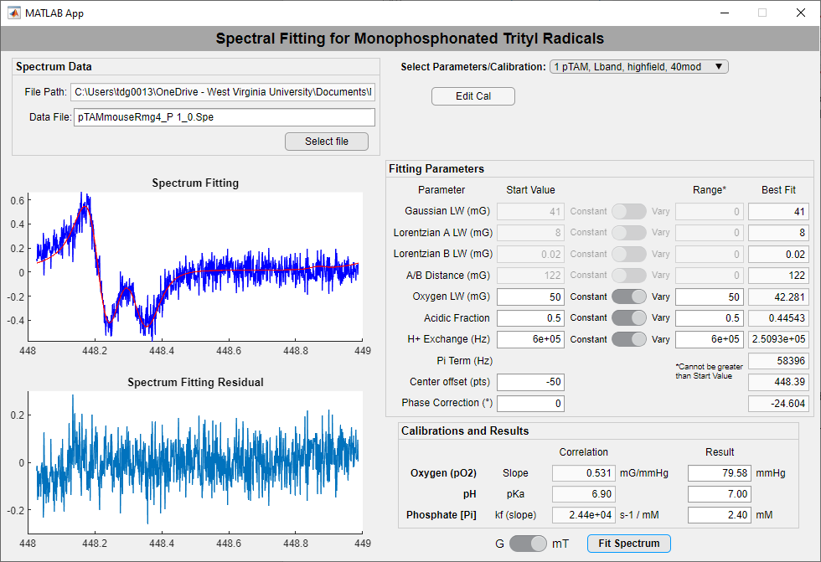

1. If the spectrum does not successfully fit due to the phase, enter a guessed degree adjustment into **Phase Correction** (example=180 to flip) and re-click **Fit Spectrum** .

*Note - Both center and phase do have some variance built into the fitting algorithm. These adjustments should only be needed for more exaggerated offset or out of phase spectra.

## **Editing a Calibration**

* 1. Select the calibration you want to work with in the drop-down menu at the top right of the application.
  2. Click **Edit Cal** below the drop down menu. This will allow you to change the fitting parameters, calibrated slopes, and pKa. The following values are saved:

**Gaussian LW, Lorentzian A LW, Lorentzian B LW, A/B Distance,**

**Oxygen slope, pKa, Phosphate slope**

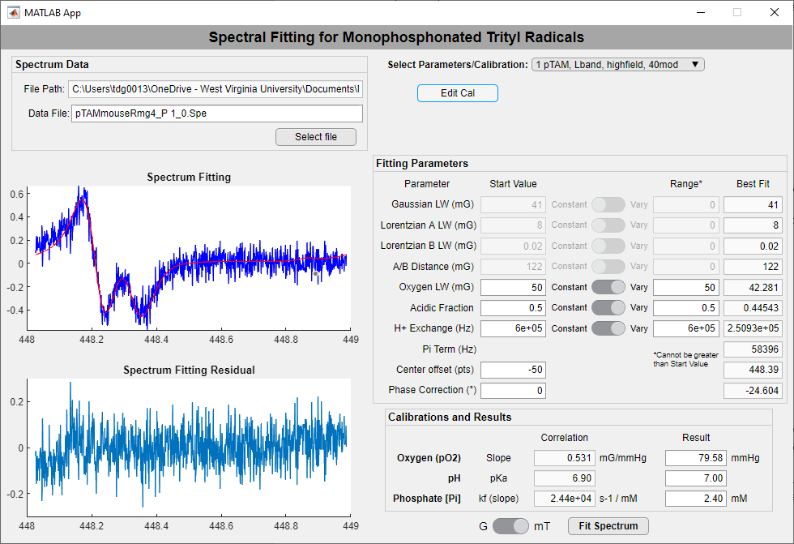

* 1. You can follow the section on pages 7-8 to fit a spectrum with your edited calibration.
  2. If you would like to save these changes to the current calibration, Click **Save Changes** . A dialog box will appear and ask if you would like to change the name of the calibration (It will default to the current name). Make any changes the name or leave it the same and click **OK** . Hitting Cancel or submitting a blank name will cancel the save.

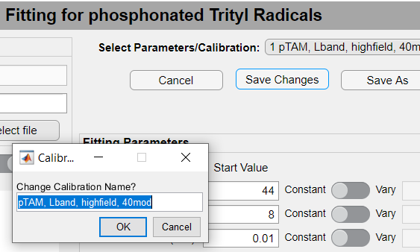

* 1. If you would like to save the changes as a new calibration, Click **Save As** . A dialog box will appear asking for the new calibration name. Enter the name you would like and Click **OK** . Hitting Cancel or submitting a blank name will cancel the save.
  2. If you would like to delete this calibration, Click **Delete Cal** . A prompt will ask you if you are sure you would like to delete this calibration. If Yes, the calibration will be deleted. If No, the deletion will be cancelled.

# **Calibration**

## **Starting a New Calibration**

1. To make a new calibration, select “0 Custom/Calibrate” the drop-down menu at the top right of the application.
2. A panel of shortcut buttons for calibration will appear below the drop-down menu.

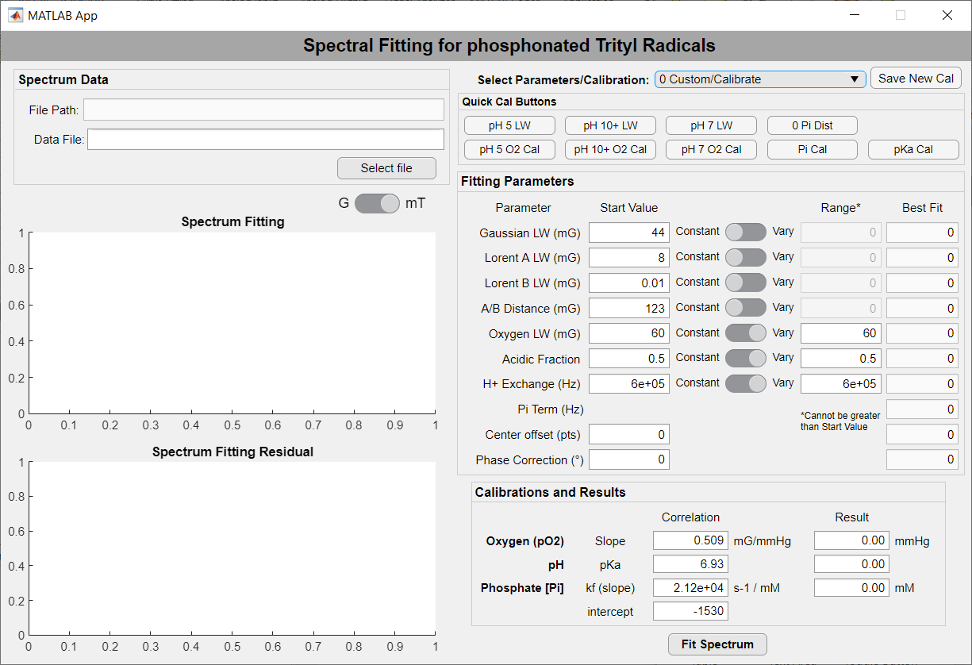

## **Determining the Fitting Parameters**

### Acidic Peak (Outer Peaks) Linewidths

**EPR Sample preparation and spectrum acquisition**

Prepare an acidic sample of suitable pTAM concentration and volume for your EPR instrument. Include NaCl and phosphate buffer as appropriate. The pH should be approximately between 4 and 5. Remove all oxygen from the sample before recording the EPR signal via a gas controller or the addition of glucose oxidase/glucose (the latter method may affect the pH).

1. With “0 Custom/Calibrate” selected and the “Quick Cal Buttons” panel showing, click **pH 5 LW** . This automatically sets the **Gaussian** and acidic peak Lorentzian (**Lorentzian A**) linewidths to vary. It also holds the oxygen-induced line broadening (**Oxygen LW**) at 0 and the **Acidic Fraction** at 1. Lorentzian B LW, A/B Distance, and H+ Exchange can be ignored with just the acidic peak present.

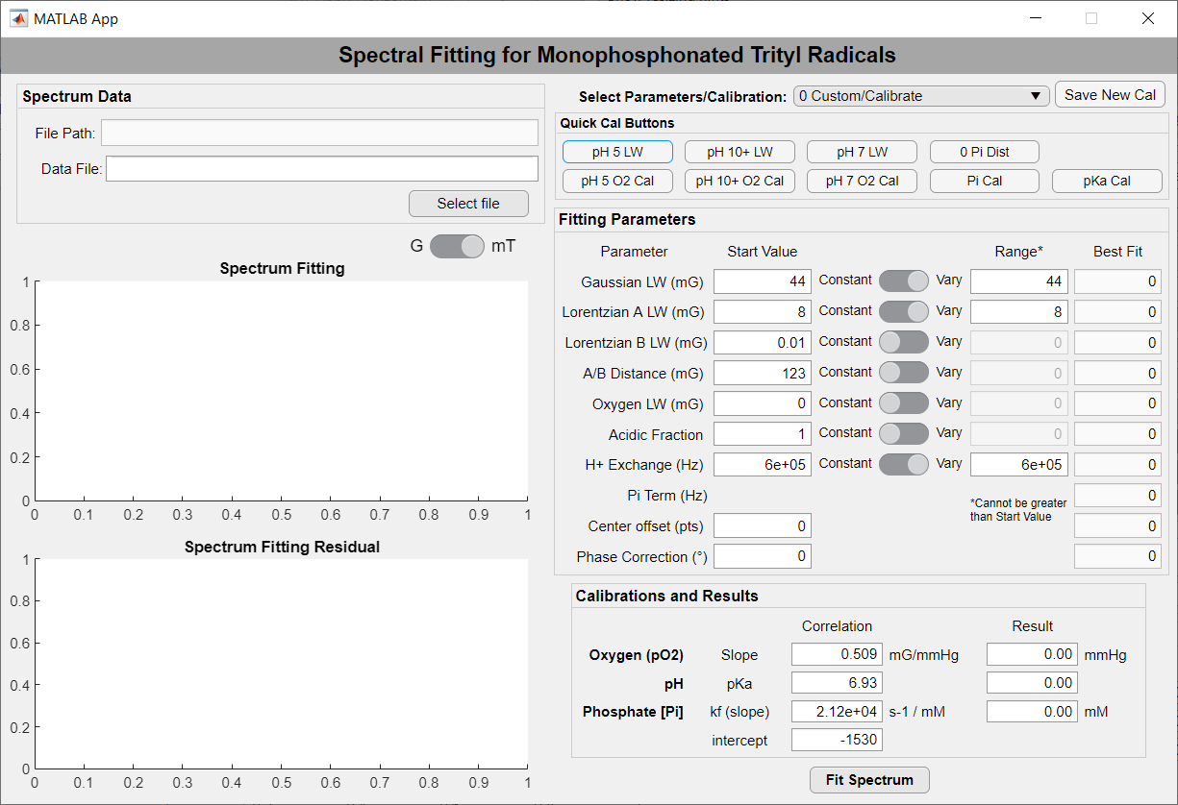

1. Select a file (see page 6) of a spectrum recorded at pH~5 and with 0% oxygen. Click **Fit Spectrum** .
2. Record the *Best Fit* results for **Gaussian LW** and **Lorentzian A LW**.
3. Repeat for all replicate spectra. Average the results for the two parameters and enter the averages into the corresponding *Start Values*.

### Basic Peak (Inner Peaks) Linewidths

**EPR Sample preparation and spectrum acquisition**

Prepare a basic sample of suitable pTAM concentration and volume for the EPR instrument. Include NaCl and phosphate buffer as appropriate. The pH should be between 10 and 12. Remove all oxygen from the sample before recording the EPR signal via a gas controller or the addition of glucose oxidase/glucose (the latter method may affect the pH).

1. With “0 Custom/Calibrate” selected and the “Quick Cal Buttons” panel showing, click **pH 10+ LW** . This automatically sets the overall **Gaussian** and basic peak Lorentzian (**Lorentzian B**) linewidths to vary. It also holds the oxygen-induced line broadening (**Oxygen LW**) at 0 and the **Acidic Fraction** at 0. Lorentzian A LW, A/B Distance, and H+ Exchange can be with just the basic peak present.
2. Select a file (see page 6) of a spectrum recorded at pH>10 and with 0% oxygen. Click **Fit Spectrum** .

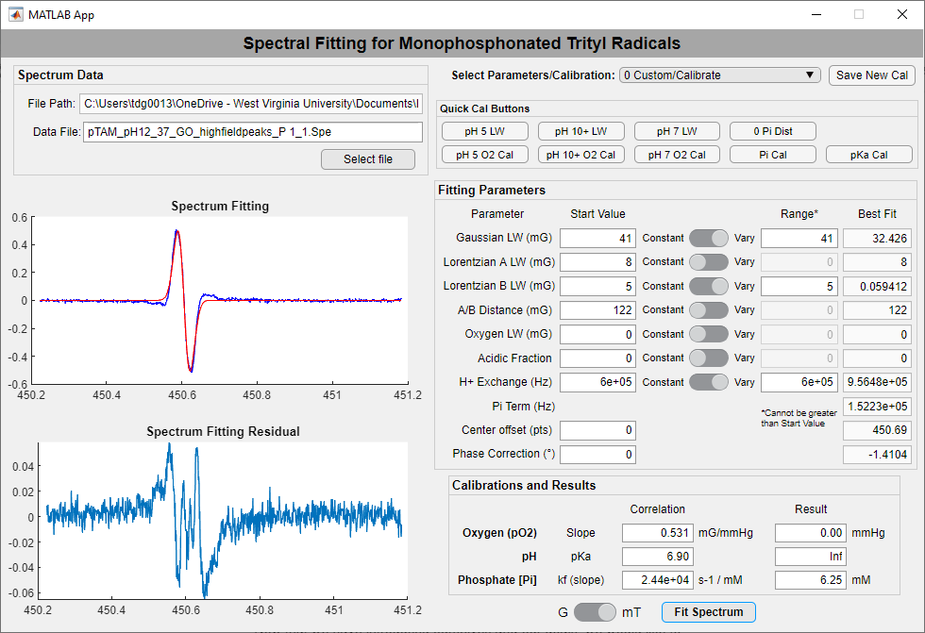

1. Record the **Best Fit** for **Gaussian LW** and **Lorentzian B LW**.
2. Repeat for all replicate spectra. Average the results for the two parameters and enter the averages into the corresponding *Start Values*.
3. Once you have fit both the acidic and basic peaks, average the **Gaussian LW** for both together for the final value. Enter that for the *Start Value*.

### A/B Distance

**EPR Sample preparation and spectrum acquisition**

Prepare a sample of suitable pTAM concentration and volume for the EPR instrument. Include NaCal as appropriate, but **do not include phosphate buffer** for determining the A/B Distance. The pH should be approximately 7. Remove all oxygen from the sample before recording the EPR signal via a gas controller.

1. With “0 Custom/Calibrate” selected and the “Quick Cal Buttons” panel showing, click **0 Pi Dist** . This automatically sets the overall **Gaussian**, acidic peak Lorentzian (**Lorentzian A**), and basic peak Lorentzian (**Lorentzian B**) linewidths to constant. Ensure they are the values you determined for this calibration (pages 10 and 11). It also holds the oxygen-induced line broadening (**Oxygen LW**) at 0 and **H+ Exchange** at 1e-5. It allows the **acidic fraction** and **A/B Distance** to vary. **A/B Distance** *Start Value* should be positive for the high-field/right component (acidic peak on right) and negative for the low-field/left component (acidic on left).
2. Select a file (see page 6) of a spectrum recorded at pH 7 with no phosphate and with 0% oxygen.
3. Click **Fit Spectrum** .

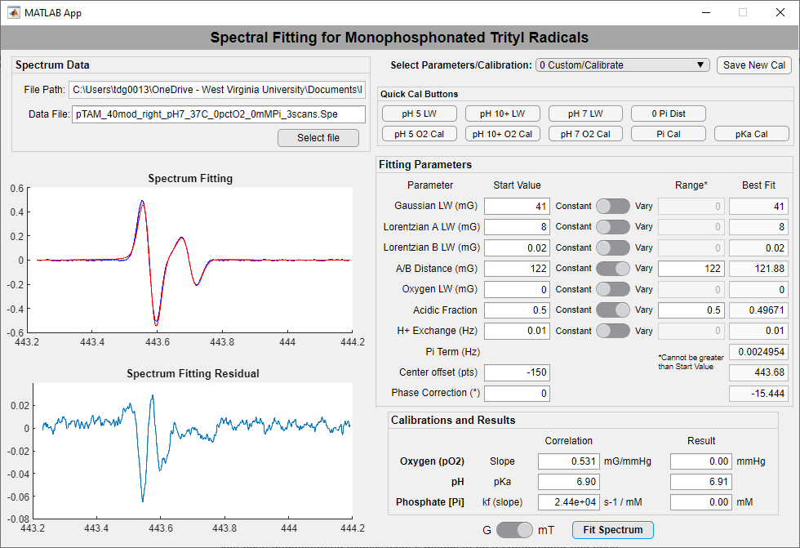

1. Record the *Best Fit* for **A/B Distance.**
2. Repeat for all replicate spectra. Average the results for the parameter and enter the average into the corresponding *Start Value*.

### Alternate - Both Peaks Linewidths (plus A/B Distance)

**EPR Sample preparation and spectrum acquisition**

Prepare a sample of suitable pTAM concentration and volume for the EPR instrument. Include NaCal as appropriate, but **do not include phosphate buffer** for determining the A/B Distance. The pH should be approximately 7. Remove all oxygen from the sample before recording the EPR signal via a gas controller.

1. With “0 Custom/Calibrate” selected and the “Quick Cal Buttons” panel showing, click **pH 7 LW** . This automatically sets the overall **Gaussian**, acidic peak Lorentzian (**Lorentzian A**), and basic peak Lorentzian (**Lorentzian B**) linewidths to vary. It also allows the **acidic fraction** and **A/B Distance** to vary. It holds the oxygen-induced line broadening (**Oxygen LW**) at 0 and **H+ Exchange** at 1e-5. **A/B Distance** *Start Value* should be positive for the high-field/right component (acidic peak on right) and negative for the low-field/left component (acidic on left).
2. Select a file (see page 6) of a spectrum recorded at pH 7 with no phosphate and with 0% oxygen.
3. Click **Fit Spectrum** .

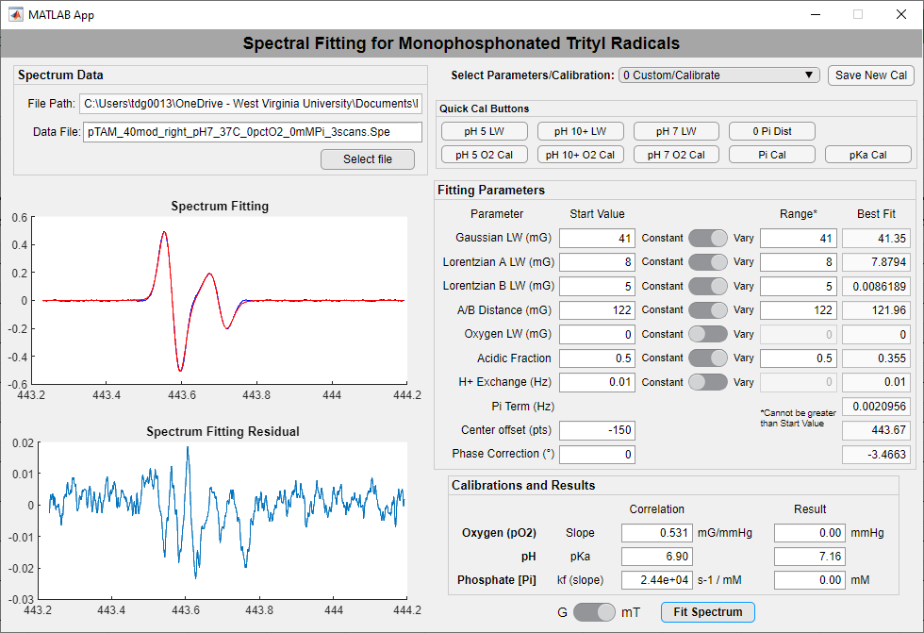

1. Record the *Best Fit* for **Gaussian LW**, **Lorent A LW**, **Lorent B LW**, and **A/B Distance.**
2. Repeat for all replicate spectra. Average the results for the four parameters and enter the averages into the corresponding *Start Values*.

## **Calibrating Slopes**

### Oxygen Slope of Acidic Peak (Outer Peaks)

**EPR Sample preparation and spectrum acquisition**

Prepare an acidic sample of suitable pTAM concentration and volume for the EPR instrument. Include NaCl and phosphate buffer as appropriate. The pH should be approximately between 4 and 5. This should be the same sample as page 10. Adjust the oxygen partial pressure surrounding or bubbled through the sample with a gas composition controller. Record the spectra at varying percentages of oxygen below air (21%).

1. Click **pH 5 O2 Cal** . This automatically sets the oxygen-induced line broadening (**Oxygen LW**) to vary. It also holds the **Gaussian** **LW** and acidic peak Lorentzian (**Lorentzian A LW**) linewidths constant and the **acidic fraction** at 1. Ensure these are the values you determined for this calibration (page 10). Lorentzian B, A/B Distance, and H+ Exchange can be ignored with just the acidic peak present.

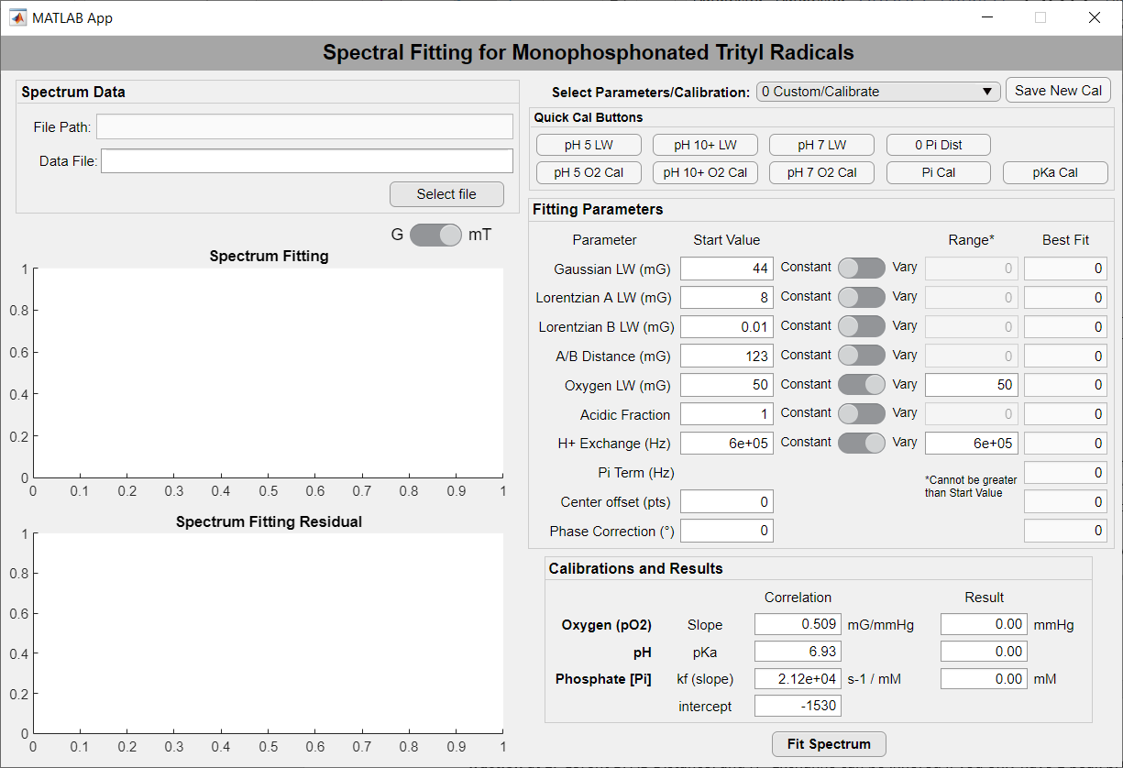

1. Select a file (see page 6) of a spectrum recorded at pH~5 with a known percentage of oxygen.
2. Click **Fit Spectrum** . Record the *Best Fit* for **Oxygen LW**.
3. Repeat for all replicate spectra.
4. Repeat for each known percentage of oxygen
5. Plot the **Oxygen LW** (y; mG) against oxygen partial pressure (x; mmHg) to determine the linear relationship/slope.
6. Once you find the acidic peak oxygen slope and the basic peak oxygen slope, average them together and enter the value for the **Oxygen (pO2) slope** in the *Calibrations and Results* section.

### Oxygen Slope of Basic Peak (Inner Peaks)

**EPR Sample preparation and spectrum acquisition**

Prepare a basic sample of appropriate pTAM concentration and volume for the EPR instrument. Include NaCl and phosphate buffer as appropriate. The pH should be between 10 and 12. This should be the same sample as page 11. Adjust the oxygen partial pressure surrounding or bubbled through the sample with a gas composition controller. Record the spectra at varying percentages of oxygen below air (21%).

1. Click **pH 10+ O2 Cal** . This automatically sets the oxygen-induced line broadening (**Oxygen LW**) to vary. It also holds the **Gaussian** **LW** and basic peak Lorentzian (**Lorentzian B LW**) linewidths constant and the **Acidic Fraction** at 0. Ensure these are the values you determined for this calibration (page 11). Lorentzian A, A/B Distance, and H+ Exchange can be ignored with just the basic peak present.
2. Select a file (see page 6) of a spectrum recorded at pH>10 with a known percentage of oxygen.
3. Click **Fit Spectrum** . Record the *Best Fit* for **Oxygen LW**.

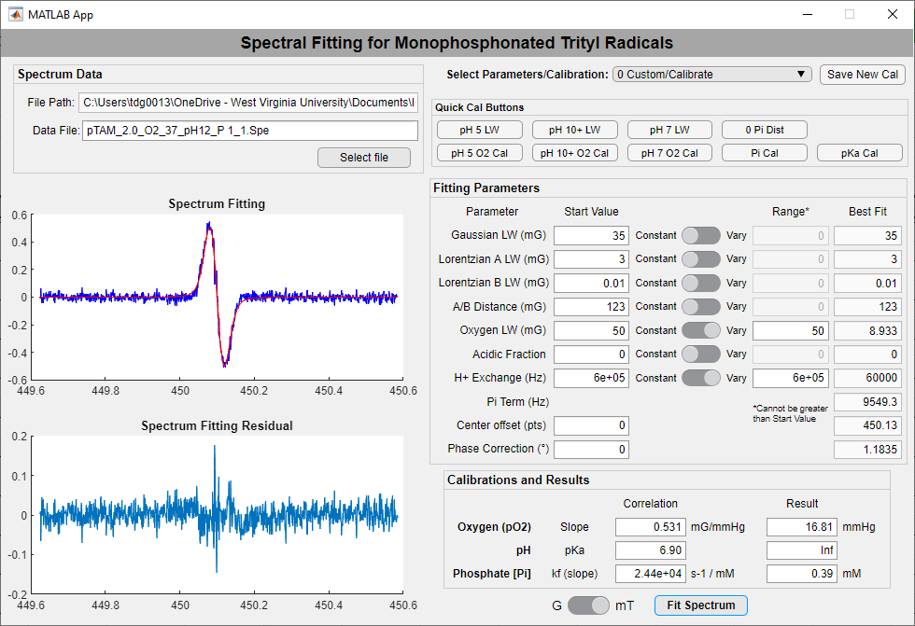

1. Repeat for all replicate spectra.
2. Repeat for each known percentage of oxygen.
3. Plot the **Oxygen LW** (y; mG) against oxygen partial pressure (x; mmHg) to determine the linear relationship/slope.

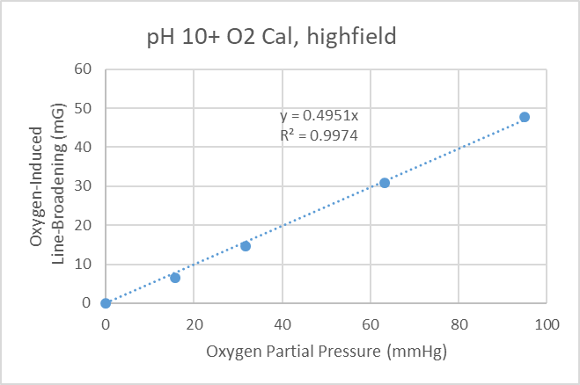

1. Once you find the acidic peak oxygen slope and the basic peak oxygen slope, average them together and enter the value for the **Oxygen (pO2) slope** in the *Calibrations and Results* section.

### Alternate - Oxygen Slope of Acidic/Basic Peaks at pH 7

**EPR Sample preparation and spectrum acquisition**

Prepare a basic sample of suitable pTAM concentration and volume for the EPR instrument. Include NaCl and phosphate buffer as appropriate. The pH should be between 10 and 12. This should be the same sample as page 11. Adjust the oxygen partial pressure surrounding or bubbled through the sample with a gas composition controller. Record the spectra at varying percentages of oxygen below air (21%).

1. Click **pH 7 O2 Cal** . This automatically sets the oxygen-induced line broadening (**Oxygen LW**) to vary. It also holds the **Gaussian** **LW**, acidic peak Lorentzian (**Lorentzian A LW**), and basic peak Lorentzian (**Lorentzian B LW**) linewidths and the **A/B Distance** constant. Ensure these are the values you determined for this calibration. It also holds the **H+ Exchange** at 1e-5 and allows the **Acidic Fraction** to vary.
2. Select a file (see page 6) of a spectrum recorded at pH~7 with a known percentage of oxygen.
3. Click **Fit Spectrum** . Record the *Best Fit* for **Oxygen LW**.

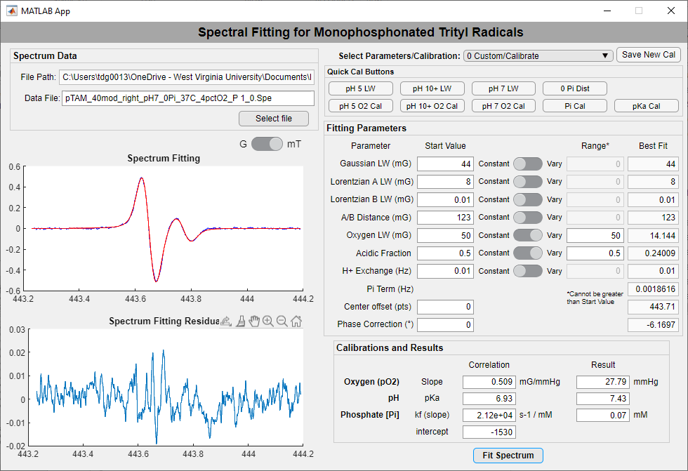

1. Repeat for all replicate spectra.
2. Repeat for each known percentage of oxygen
3. Plot the **Oxygen LW** (y; mG) against oxygen partial pressure (x; mmHg) to determine the linear relationship/slope.
4. Once you find the oxygen slope, enter the value for the **Oxygen (pO2) slope** in the *Calibrations and Results* section.

### Phosphate Slope and Intercept

**EPR Sample preparation and spectrum acquisition**

Prepare several samples of suitable pTAM concentration and volume for the EPR instrument. Include NaCal as appropriate. Include different concentrations of inorganic phosphate up to 10mM. The pH of all should be approximately 7. Remove all oxygen from the samples before recording the EPR spectra via a gas controller.

1. Click **Pi Cal** . This automatically sets the **Acidic Fraction** and **H+ Exchange** to vary. It also holds the **Gaussian** **LW**, acidic peak Lorentzian (**Lorentzian A LW**), and basic peak Lorentzian (**Lorentzian B LW**) linewidths and the **A/B Distance** constant. Ensure these are the values you determined for this calibration. It also holds the **Oxygen LW** constant at 0.
2. Select a file (see page 6) of a spectrum recorded at pH~7 with no oxygen and a known concentration of inorganic phosphate [Pi].
3. Click **Fit Spectrum** . Record the *Best Fit* for **Acidic Fraction**, **H+ Exchange**, and **Pi Term**.

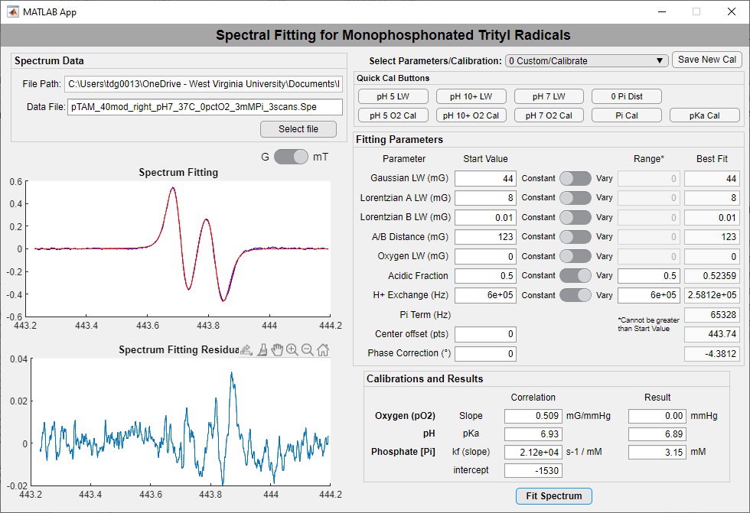

1. Repeat for all replicate spectra.
2. Repeat for each known concentration if inorganic phosphate.
3. Plot the **Pi Term** (y; 1/s) against inorganic phosphate concentration (x; mM) to determine the linear relationship/slope.
4. 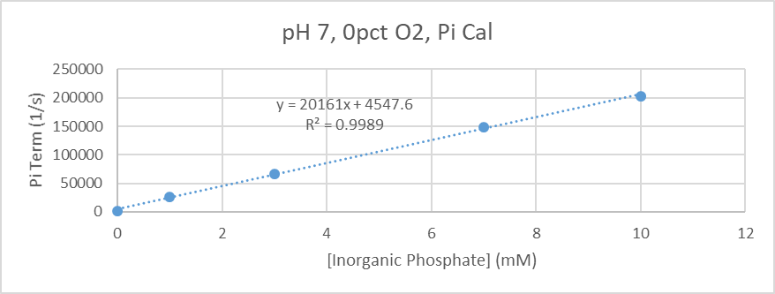Once you find the equation for the line, enter the values for the **Phosphate [Pi] slope** (k*f*) in the *Calibrations and Results* section.

### pKa

**EPR Sample preparation and spectrum acquisition**

Prepare a solution of suitable pTAM concentration for the EPR instrument and volume for titration and accurate pH measurement. Include NaCal as appropriate and 1mM phosphate buffer. The pH should be between 6 and 8. Bubble in nitrogen, record pH, and take a sample for EPR measurement. Control gas composition in sample to all nitrogen before recording the EPR spectra. Titrate the solution with weak solutions of NaOH or HCl to adjust the pH to 5 or more values between 6 and 8. Repeat anerobic EPR measurements for each pH.

Note – only necessary if pKa is not known or defined in literature.

1. Click **pKa Cal** . This automatically sets the **Acidic Fraction** and **H+ Exchange** to vary. It also holds the **Gaussian** **LW**, acidic peak Lorentzian (**Lorentzian A LW**), and basic peak Lorentzian (**Lorentzian B LW**) linewidths and the **A/B Distance** constant. Ensure these are the values you determined for this calibration. It should also hold the **Oxygen LW** constant at 0.
2. Select a file (see page 6) of a spectrum recorded with no oxygen and a known pH between 6 and 8.
3. Click **Fit Spectrum** . Record the *Best Fit* for **Acidic Fraction**.
4. Repeat for all replicate spectra.
5. Repeat for each known pH.
6. Plot the **Acidic Fraction** (y) against pH (x) to plot the titration curve.
7. Fit the data using the equation to find pKa:



1. Once you find the pKa, enter the value for the **pKa** in the *Calibrations and Results* section.

## **Saving the New Calibration**

1. Select “0 Custom/Calibrate” in the drop-down menu at the top right of the application, if not already done.
2. Make sure all of your determined fitting parameters are entered into the *Start Values* and calibrated slopes/intercepts/pKa are entered into the *Calibration and Results* section under *Correlation*. The following values are saved:

**Gaussian LW, Lorentzian A LW, Lorentzian B LW, A/B Distance,**

**Oxygen slope, pKa, Phosphate slope**

1. Click **Save New Cal** .
2. A dialog box will appear asking for the new calibration name. Enter the name you would like and Click OK . Hitting Cancel or submitting a blank name will cancel the save.

# **Additional Notes**

## **Saved Calibration File**

* The calibrations are saved in a text file *pTAM_cal.txt*, which should be in the same directory as the software’s exe file. If you installed the application in a read-only folder such as “C:\Program Files\pTAM_Fitting_App\”, a writeable copy of *pTAM_cal.txt* will be created in your user directory (Example – “C:\Users\[username]\pTAM_Fitting_App\”).
* The software will still run without *pTAM_cal.txt*, but will not load any existing calibrations and will only provide the Custom/Calibrate option. You may save a new calibration and the txt file will be created.
* The text file must have the following format to be read correctly (9 items across):

1|pTAM, Lband, highfield, 40mod|41|8|0.02|122|0.53127|6.90|24365

2|sample|42|5|5|125|0.5|7.00|25000

in which the fields are arranged in this order (separated by |)

index|name|Gaussian LW|Lorentzian A LW|Lorentzian B LW|A/B Distance|Oxygen slope|pKa|Phosphate slope